|  |  |  |  |
| --- | --- | --- | --- |
|  | Bansilal Ramnath Agarwal Charitable Trust's  Vishwakarma Institute of Information Technology  **Department of**  **Artificial Intelligence and Data Science** | | |
| Student Name: Siddhesh Dilip Khairnar | | | |
| Class: SY | Division: B | | Roll No: 272028 |
| Semester: 3rd | | Academic Year: 2022 - 23 | |
| Subject Name & Code: ADUA21206: Data Visualization | | | |
| Title of Assignment: **Visualize**  **the dataset using temporal category and Timelines tools** | | | |
| Date of Performance: | | Date of Submission: | |

Aim: Visualization of dataset using Python/R

Problem Statement:

1.Write various commands for dealing with datasets and briefly discus them. 2.Write instruction generating bar chart, pie chart.

1. Create bar chart, pie chart using datasets. Dataset:

Link(bar chart) : [https://kaggle.com/code/spscientist/student-performance-in-](https://kaggle.com/code/spscientist/student-performance-in-exams/data) [exams/data](https://kaggle.com/code/spscientist/student-performance-in-exams/data)

Pie chart dataset :

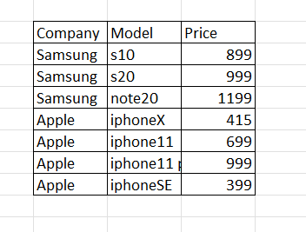

# Software Used:

Google Collab Notebook

Background Information:

Dataset:

* 1. So here I taken a dataset of student performance in exams for plotting bar graph in Python.
  2. Secondly, I Created my own dataset for creating Pie chart in the Python.
  3. Both datasets are different but connected through the google collab software.

1. Write various commands for dealing with datasets and briefly discus them.

ANS: One of the best commands in Python language is Pandas **PANDAS:** Pandas is one of the most popular tools for data analysis in Python. This open-source library is the backbone of many data projects and is used for data cleaning and data manipulation.

With Pandas, you gain greater control over complex data sets. It’s an essential tool in the data analysis tool belt. If you’re not using Pandas, you’re not making the most of your data.

Steps to create any chart in python

* 1. First of all, import all the modules like matplotlib, pandas

, NumPy in the python code.

* 1. Create a variable df and run the csv file read union to read the csv file.
  2. Save the csv file in the Collab file directory.
  3. Copy its path and paste it in the main code read function.
  4. Then just give the attributes you want.
  5. Mention the type of graph in the plot () function.
  6. Call the plt.show function.(we considered matplotlib as plt in the code while importing)

# Visualizations:

**Observation:** We Had Implemented the python code for both bar and Pie Charts ...

# Code For Bar chart and its output

1. 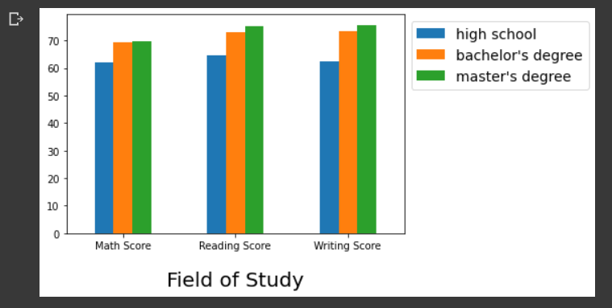Output:
2. 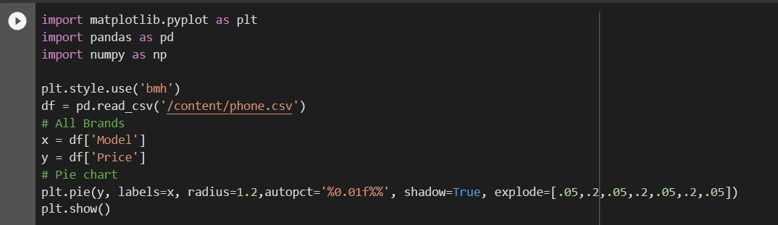Code for Pie Chart in Python
3. Output of the Code

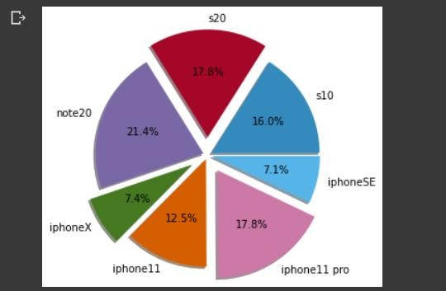

Collab Notebook Link:

https://colab.research.google.com/drive/15fX8sp_nEXniJKIXfQzIMFt G2Pr8z-Hg#scrollTo=zjnNr4FUbIOc

Conclusion:

Here we learned that how can we also do visualizations through the coding. Here we connect a dataset in python and using the various modules like NumPy

, matplotlib, pandas we implemented the logic of coding and plot the graphs and charts in the output of the program. We learned about the panda’s library which performs a greater role in the implementation of charts in the python.

So, we can conclude that we successfully learned the use of pandas and matplotlib library to implement graphical charts in the output and also learned about the various type of connectivity done for building the charts through the coding.